TEAM MEMBERS

Plagiarism Policy
Plagiarism is the representation of another's words, ideas, or work as one’s own. It is the student’s responsibility to self-educate on what constitutes plagiarism. All students are responsible for reading and understanding these rules and abide by the signed and submitted Academic Integrity Statement.
- Students may not show their solutions to the homework assignments to other students before the submission deadline.
- Students may discuss lecture materials, but they may not discuss homework assignments with their classmates.
- Unless otherwise stated, students may collaborate on assignments with others within the same group. For this course, all homework assignments are group efforts and only the project is a joint effort venture.

All submissions should be the original works. Any incidence of plagiarism (any exchange, reuse, or direct submission of other’s work, e.g., documents, code etc., as your own or as your team’s) or other academic dishonesty will be discussed with the student. Students found guilty of plagiarism can expect a Drexel University Alleged Academic Misconduct Report to be filed to the University Judicial Office, where a permanent record is maintained and result in an F for this course.

Academic Integrity Statement
To ensure adherence to the academic honesty policies, all students are required to sign and submit the following statement.

I certify that:
- Homework, project, exams and/or all other assignments in this course will be entirely my own original work, produced in response to the specific course requirements.
- I will not quote the words of any other person from a printed source or a website without indicating what has been quoted and providing an appropriate citation.
- I will not submit my work in this course to satisfy the requirements of any other course nor will I use the same work from any other course to satisfy the requirements of this course.

Full Name | Username (abc123) | Date | Signature (initials)
Anamika Rekha | ar3876 | 2/5/2023 | AR
Vijval Vemula | vv354 | 2/5/2023 | VV
Priyanka Patil | pp673 | 2/5/2023 | PP
Abhishek Mohan Patil | ap3869 | 2/5/2023 | AMP

PROJECT TITLE: Synthetic Clinical Patient Database

Using the data available in the following tables, write queries to respond the proposed questions and provide a screen shot with the result.

SELECT * FROM hc848.MITRE_PATIENT;
SELECT * FROM hc848.MITRE_PATIENT_ALLERGY;
SELECT * FROM hc848.MITRE_PATIENT_IMAGING_STUDY;
SELECT * FROM hc848.MITRE_PATIENT_IMMUNIZATION;
SELECT * FROM hc848.MITRE_PATIENT_MEDICATION;
SELECT * FROM hc848.MITRE_PATIENT_PROCEDURE;

You MUST refer to tables using the prefix “hc848” – do not use any tables created in your own account.

Question 1 | What is the most common allergy for each marital status?
Query (SQL) | select * from  (  select mid.*, rank() over (partition by marital_status order by pat_count desc) rank  from  (  select p.marital_status, a.allergy_description, count(*) as pat_count  from hc848.mitre_patient p  join hc848.mitre_patient_allergy a on p.patient_id = a.patient_id  group by p.marital_status, a.allergy_description  ) mid  )  where rank = 1  order by pat_count desc;
Result | 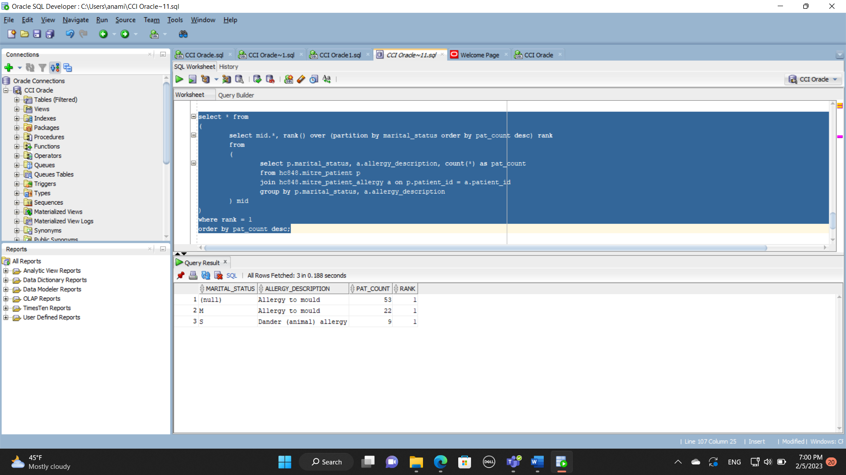

Question 2 | What is the number of patients in each different type of allergy?
Query (SQL) | SELECT ALLERGY_CODE,ALLERGY_DESCRIPTION,COUNT(DISTINCT PATIENT_ID)  FROM hc848.MITRE_PATIENT_ALLERGY  WHERE PATIENT_ID IS NOT NULL  GROUP BY ALLERGY_CODE,ALLERGY_DESCRIPTION ;
Result | 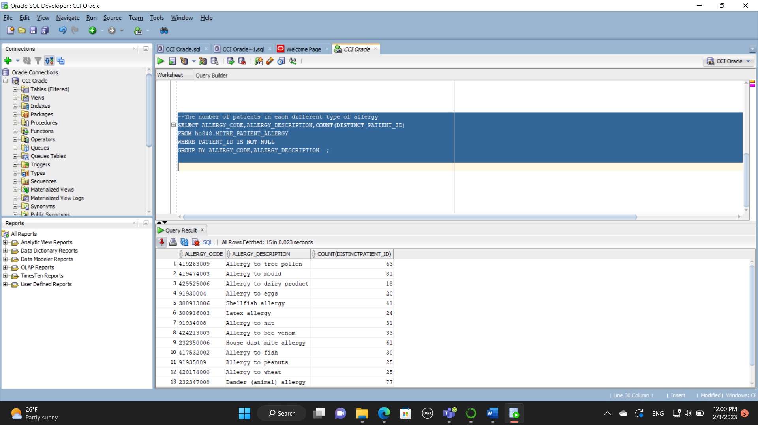

Question 3 | How many patients have no records of allergy in their medical history?
Query (SQL) | SELECT COUNT(DISTINCT hc848.MITRE_PATIENT.PATIENT_ID)  FROM hc848.MITRE_PATIENT  LEFT JOIN hc848.MITRE_PATIENT_ALLERGY  ON hc848.MITRE_PATIENT.PATIENT_ID=hc848.MITRE_PATIENT_ALLERGY.PATIENT_ID  WHERE hc848.MITRE_PATIENT_ALLERGY.PATIENT_ID IS NULL;
Result | 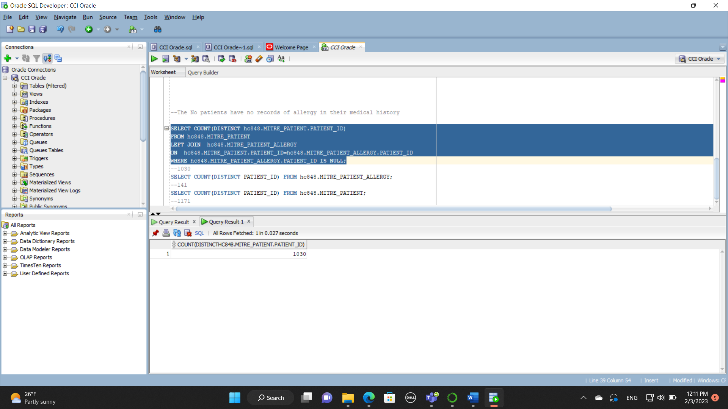

Question 4 | What is the percentage of patients (0-100%) that have NOT taken any immunizations yet?
Query (SQL) | select count(distinct i.patient_id) as vaccined,  count(distinct p.patient_id) as over_all,  round(100- (count(distinct i.patient_id)/count(distinct p.patient_id) *100),2) AS percent_unvaccined  FROM hc848.mitre_patient p  left join hc848.mitre_patient_immunization i  on i.patient_id = p.patient_id;
Result | 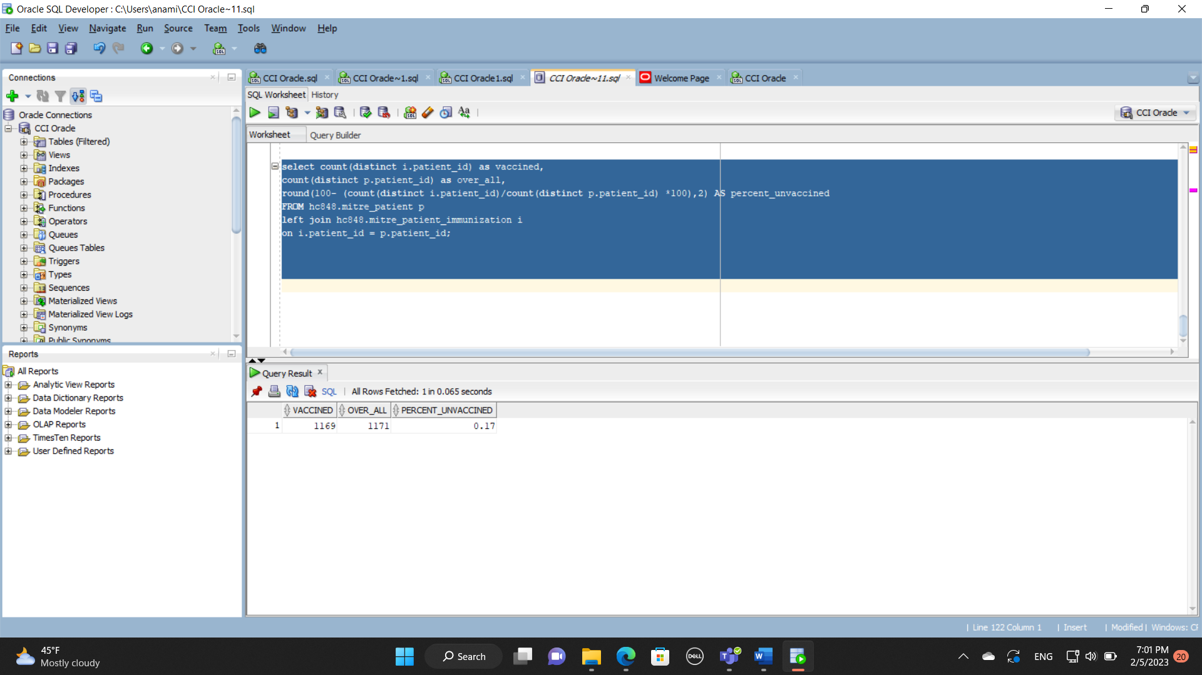

Question 5 | What is the most common medication used for patients submitted to each one of the procedures?
Query (SQL) | SELECT hc848.MITRE_PATIENT_PROCEDURE.PROCEDURE_CODE, hc848.MITRE_PATIENT_MEDICATION.MEDICATION_DESCRIPTION, COUNT( hc848.MITRE_PATIENT_MEDICATION.MEDICATION_CODE) MEDICATION_COUNT  FROM hc848.MITRE_PATIENT_PROCEDURE  JOIN hc848.MITRE_PATIENT_MEDICATION  ON hc848.MITRE_PATIENT_PROCEDURE.PATIENT_ID = hc848.MITRE_PATIENT_MEDICATION.PATIENT_ID  GROUP BY hc848.MITRE_PATIENT_PROCEDURE.PROCEDURE_CODE, hc848.MITRE_PATIENT_MEDICATION.MEDICATION_DESCRIPTION  ORDER BY hc848.MITRE_PATIENT_PROCEDURE.PROCEDURE_CODE, COUNT(hc848.MITRE_PATIENT_MEDICATION.MEDICATION_DESCRIPTION) DESC;
Result | 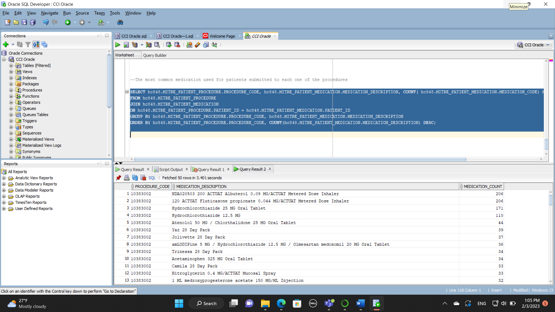

Question 6 | How many different modalities of imaging study are observed in each body site?
Query (SQL) | SELECT COUNT(MODALITY_CODE),BODYSITE_DESCRIPTION,BODYSITE_CODE  FROM hc848.MITRE_PATIENT_IMAGING_STUDY  GROUP BY BODYSITE_DESCRIPTION,BODYSITE_CODE ;
Result | 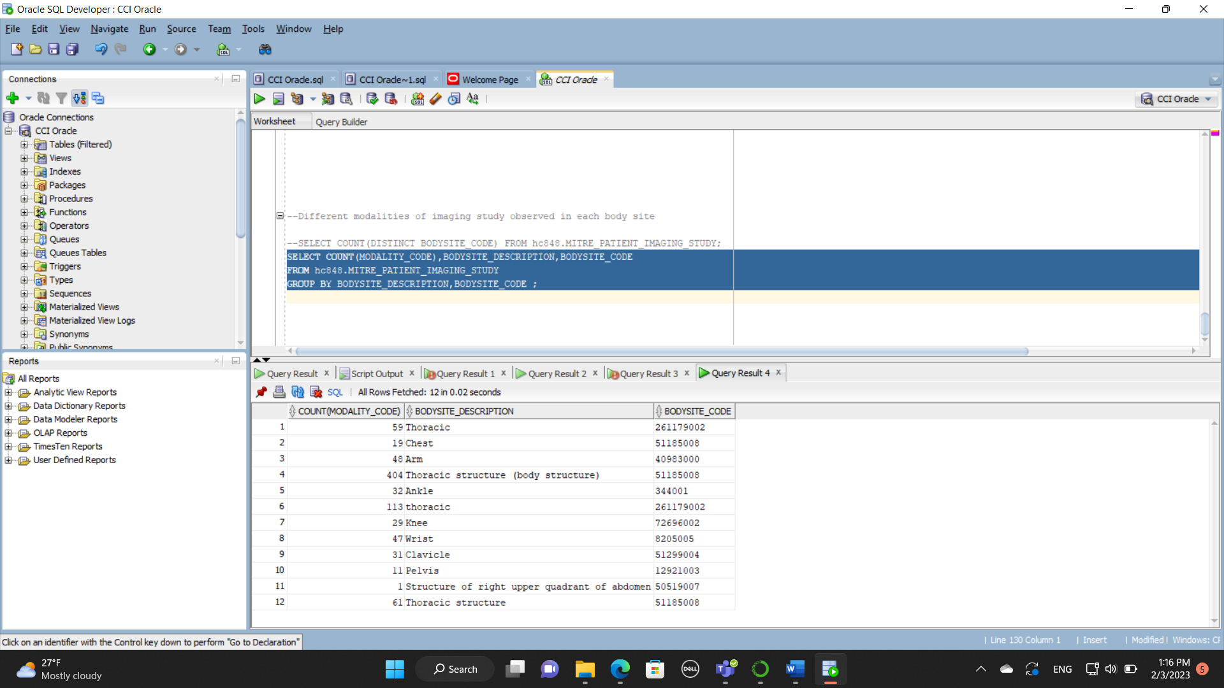

Question 7 | What is the most common modality of imaging study in each “ankle” and “wrist” (body site)?
Query (SQL) | SELECT MODALITY_CODE,COUNT(MODALITY_CODE),BODYSITE_DESCRIPTION,BODYSITE_CODE  FROM hc848.MITRE_PATIENT_IMAGING_STUDY where BODYSITE_DESCRIPTION = 'Ankle' or BODYSITE_DESCRIPTION = 'Wrist'  GROUP BY BODYSITE_DESCRIPTION,BODYSITE_CODE,MODALITY_CODE ;
Result | 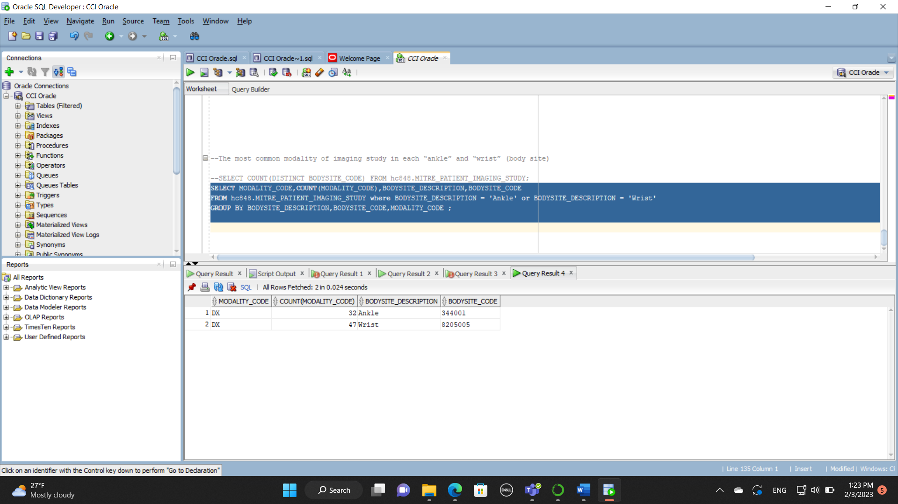

Question 8 | What is the most common procedure in each gender?
Query (SQL) | SELECT PD,G,MAX(CT)  FROM (  SELECT a.GENDER G,b.PROCEDURE_DESCRIPTION PD,COUNT(B.PROCEDURE_CODE) CT  FROM hc848.MITRE_PATIENT a  JOIN hc848.MITRE_PATIENT_PROCEDURE b  on a.PATIENT_ID=B.PATIENT_ID  GROUP BY a.GENDER,B.PROCEDURE_DESCRIPTION  ORDER BY a.GENDER,COUNT(B.PROCEDURE_CODE) DESC)  GROUP BY G,PD  ORDER BY MAX(CT) DESC  ;
Result | 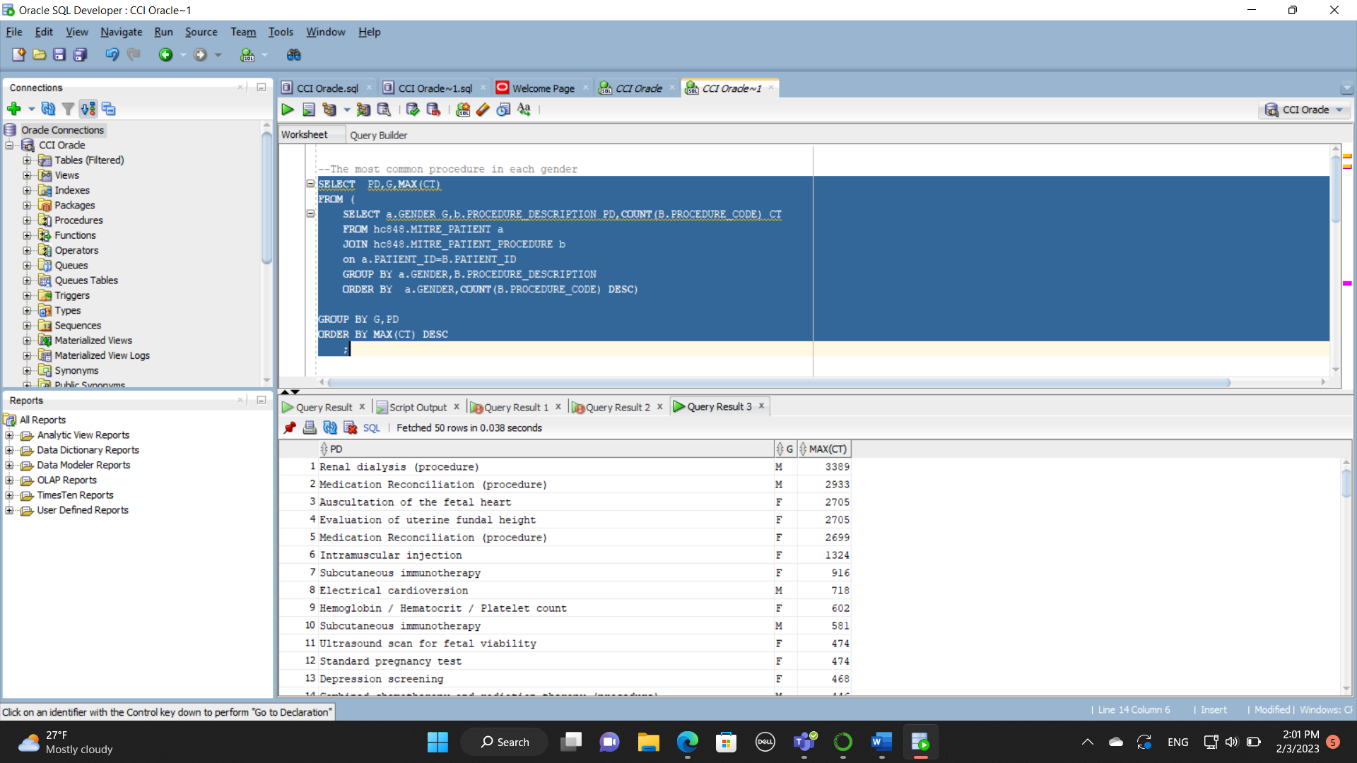

Question 9 | What is the number of patients that have NOT taken Flu immunization yet?
Query (SQL) | SELECT count(distinct(a.Patient_id))  FROM hc848.MITRE_PATIENT a  JOIN hc848.MITRE_PATIENT_IMMUNIZATION b  on a.PATIENT_ID=B.PATIENT_ID and b.IMMUNIZATION_DESCRIPTION !='Influenza seasonal injectable preservative free'  -- WHERE IMMUNIZATION_CODE IS NULL;
Result | 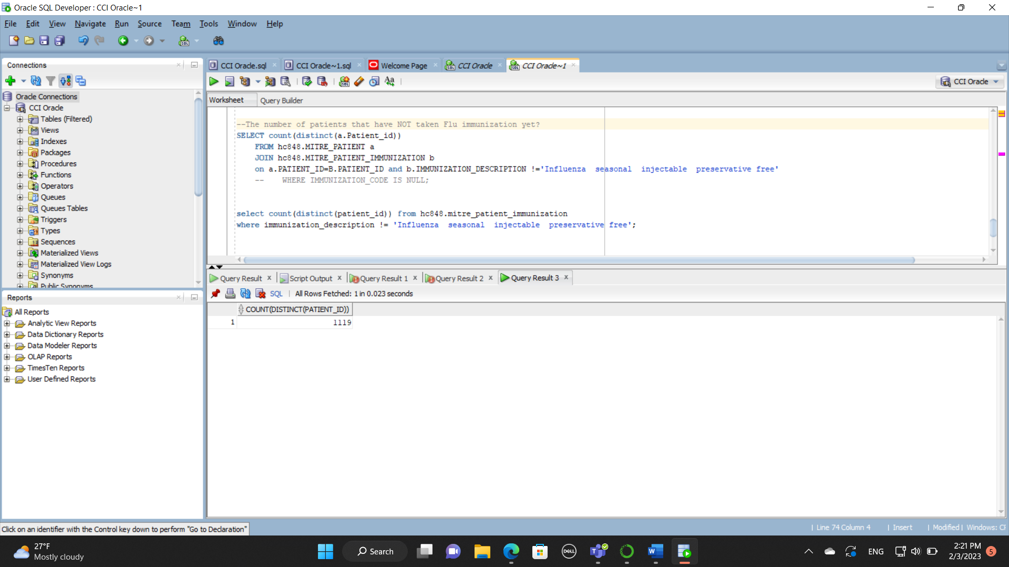

Question 10 | What is the most common reason for procedures in each gender between young and adult patients? use 18-years-old as a reference to split.
Query (SQL) | select * from  (  select mid.*, rank() over (partition by gender, adult_or_young order by pat_count desc) as ranks  from  (  select p.gender, proc.reason_description,  case  when round((sysdate - p.birthdate) / 365, 0) < 18 then 'y'  when round((sysdate - p.birthdate) / 365, 0) >= 18 then 'a'  end adult_or_young, count(*) pat_count  from hc848.mitre_patient p  join hc848.mitre_patient_procedure proc on p.patient_id = proc.patient_id  where proc.reason_description is not null  group by p.gender, proc.reason_description,  case  when round((sysdate - p.birthdate) / 365, 0) < 18 then 'y'  when round((sysdate - p.birthdate) / 365, 0) >= 18 then 'a'  end  ) mid  )  where ranks = 1;
Result | 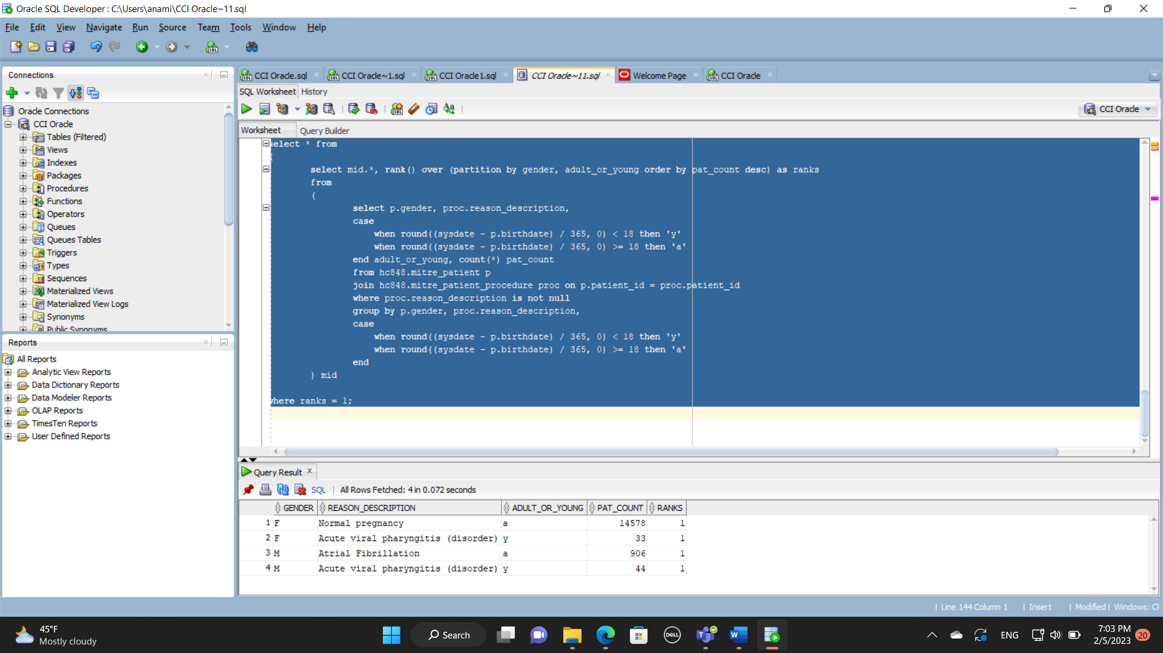

SUBMISSION

This document in Word format (not PDF).

